Screen 4 (FOR THEME 1)=

Topic heading (displayed above the grid): Today's theme: Off the beaten path, on purpose.

The 16 words and their groups
Group 1 — Straightforward (Green)
- Subtopic name (shown as hint and on solve): Common ecotourism activities
- Words: HIKING · SNORKELLING · BIRDWATCHING · KAYAKING
- Archetype trigger tag: actions_solutions
- Maps to archetype: The Activist ✊
Group 2 — Medium (Blue)
- Subtopic name (shown as hint and on solve): Where ecotourists go
- Words: RESERVE · TRAIL · LODGE · SANCTUARY
- Archetype trigger tag: places_observation
- Maps to archetype: The Explorer 🧭
Group 3 — Tricky (Orange)
- Subtopic name (shown as hint and on solve): What makes tourism eco
- Words: CONSERVATION · SUSTAINABILITY · EDUCATION · RESPECT
- Archetype trigger tag: causes_mechanisms
- Maps to archetype: The Scientist 🔬
Group 4 — Devious (Red)
- Subtopic name (shown as hint and on solve): People who run ecotourism sites
- Words: GUIDE · RANGER · MONITOR · STEWARD
- Archetype trigger tag: systems_people
- Maps to archetype: The Observer 👁

SCREEN 5 (FOR THEME 1) =

Post-game fact card (shown after puzzle ends, win or lose {lose is if all the 4 mistakes are over})
Card text:
Ecotourism is one of the fastest-growing segments of the global tourism industry, but the term has no single, universally binding legal definition. The International Ecotourism Society defines genuine ecotourism through 7 principles: covering impact reduction, cultural awareness, conservation funding, community empowerment, and low-impact design. Without these, it's just tourism with a green label.
Archetype action prompts (for the post-game archetype card)
When the player's archetype is calculated, display the matching prompt below — tailored specifically to today's ecotourism topic:
Heading = ‘Your solver DNA reveals that you are…’
- The Activist ✊ — "The Activist: You jumped straight to what to do. Plan your next trip with one ecotourism principle in mind - pick a destination that gives back to its community."
- The Explorer 🧭 — "The Explorer: You think about where to go. Find one ecotourism destination within 2 hours of where you live - there's probably one you've never heard of."
- The Scientist 🔬 — "The Scientist: You spot the principles before the action. Today, read up on what separates real ecotourism from greenwashing - it's a surprisingly murky industry."
- The Observer 👁 — "The Observer: You see who's holding things together. Look up the rangers, guides, and stewards near you - many run free walks you can join."

Implementation notes for Claude Code
- Hint behaviour: When the player taps Hint, reveal one of the four subtopic names (from "Subtopic name" above) as a banner above the grid for 7 seconds. Only reveal subtopics for groups that haven't been solved yet. Prefer subtopics not yet shown in this session. Disable the Hint button when only one group is left unsolved or while a hint banner is currently displayed.
but the game needs to display only 1 subtopic at once and if the student clicks on hint again then display another subtopic - so if the student hasnt got any set yet then it can display any of the 4 subtopics but if the student has completed a particular set then it can display any of the other 3 sets remaininng.
- Difficulty colours on solve:
  - Green (Straightforward)
  - Blue (Medium)
  - Orange (Tricky)
  - Red (Devious)
For eg –
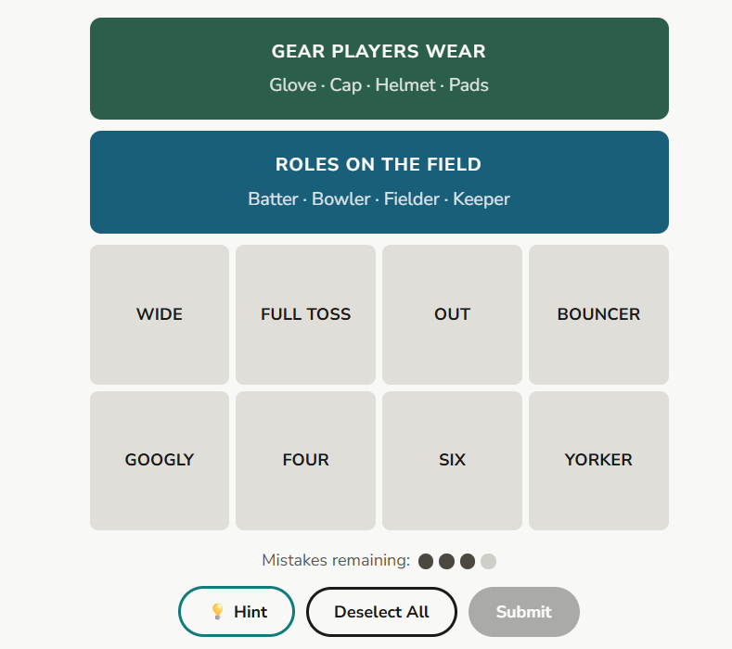
- Archetype tracking (localStorage): On puzzle completion, record which group the player solved first — increment a counter for the matching archetype tag (actions_solutions, places_observation, causes_mechanisms, systems_people). Also store: total mistakes used (0–4), total hints used, time taken in seconds, and whether the puzzle was won or lost. Archetype card unlocks after 5 puzzles completed (use a config flag to lower this to 2 for the in-class trial).
- Game end conditions: Win = all 4 groups solved. Loss = 4 mistakes used. On both win and loss, reveal all unsolved groups with an animated snap-into-place over 2–3 seconds, then show the fact card. Only show the archetype card if the player wins
- Mistakes counter: 4 mistakes allowed total.
as for the mistakes - student gets 4 chances so everytime it makes a mistake by selecting a wrong set, it loses one chance which needs to be displayed on screen and if all 4 chances get over then a message will be displayed something like 'uh oh ran out of chances' (i will give you this message when we reach this stage).

Mistakes deisgn on right side next to the puzzle but puzzle should be in the middle = Temperature gauge A horizontal thermometer-style bar that fills from left to right as mistakes accumulate, with the fill colour shifting from cool blue → yellow → orange → red across the 4 segments. The label could change too: "0/4: Stable climate" → "4/4: Tipping point reached." This turns the mistake tracker into a teaching device — every time someone makes a mistake, they're literally watching a climate metaphor play out. Strongest tie to your educational rationale.
- as for the puzzle word combinations in the sense each puzzle will have 16 words jumbled (4 sets of 4 words) so the game (or localstorage whatever) needs to remember which are the correct words under each set so the student can select the word in any order but it needs to be the correct 4 words selected back to back. so if one of the sets has 'apple, banana, pear, orange' under it but the student selects 'banana, orange, spoon, pear' then its wrong because the student selected spoon instead of apple and spoon was a word from another set. student can complete any set first, there is no restriction on that as long as the words are correct. so if the set is right then the words will get highlighted in green or something to depict its correct and if its not then red (these design details we will figure later)

